Usage:
Video Diagnostic tool used to search void/confined spaces.

Specifications:
- 5” Color LCD Video Screen
- High Speed CCD color camera with built in LED lights
- Ring Adapter
- Camera articulates up to 135 degrees
- 2’ to 4’ extension pole

operations:

- Connect camera to desired adapter. (18” Wand, 2’-4’ extension pole, or ring adapter)
- Connect appropriate monitor/camera head connector cable to adapter and monitor
- Depress power button (Center/Green)
- Manipulate selected adapter to view images
- Increase light intensity as needed (Red Button, three different settings)
- Rotate picture as necessary (Blue Button)

Maintenance:

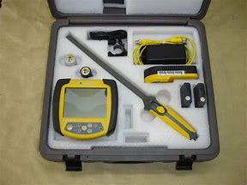
- Wipe clean all components after use
- Check all cords for damage
- Rotate batteries every Monday per schedule
- Check camera lens for damage
- Replace all components in the carrying case

