PURPOSE

This SOP establishes department procedures for the use of department power saws and equipment. It has been developed so firefighters can perform their tasks quickly and safely. All power equipment operations shall follow this procedure.

SCOPE

This policy applies to all fire department employees whose position within the agency requires them to operate power saws/equipment.

PROCEDURE

Personnel Protection: Full safety clothing shall be worn by employees operating and in close proximity to the operation. Eye protection or SCBA facepiece shall be worn to provide eye protection while power equipment is being used.
- OPERATING PROCEDURES
- Saws shall be started one (1) of two (2) ways: (1) by placing the saw on the ground; or (2) by drop starting.
- The power saw shall be carried, while running, with the chain brake on and with the blade facing away from the user and additional personnel in the work space.
- Ensure firm footing before operating any power equipment or saw.
- All unattended power saws/equipment shall either be shut off when unattended or placed in a safe area away from other people.
- Saw cuts shall be made at full throttle only.
- Power saw operations are the safest when cutting on horizontal surfaces near ground level or vertical surfaces at waist level.
- Be aware of type of material being cut prior to using power equipment.
- When operating power equipment close to highly combustible or flammable materials, use care to prevent ignition from sparks.
- Do not operate saws or other power equipment in suspected flammable or explosive atmospheres.
- While operating a power saw, side pressure or twisting of the blade or bar should be avoided; such force may cause the blade or bar to shatter during use, potentially injuring the operator and others in the immediate area.
- While operating a power saw, excessive force of on the blade should be avoided; such force may cause the blade or bar to shatter during use, potentially injuring the operator and others in the immediate area.
- Carbide tipped chains are specifically designed for structural firefighting and should be used only in structural firefighting applications.
- All Type 3 wildland apparatus shall have a wood chain 36RM72 part #: 36520050072. All structural and ARFF apparatus shall have heavy duty carbide chain (RDR) 36RDR72 part #: 39440050072.
- FUELING AND MAINTENANCE.

Observe all safety regulations on the safe handling of fuel as seen on the product label. When it is necessary to refuel, comply with the following:

- Equipment should never be refueled while running.
- Fuel shall be department issued 50:1 premix or 4-cycle fuel to be used in correct engines.
- Fill oil reservoirs whenever equipment is low.
- Oil shall be Chain and Bar Lubricant.
- 30 or 40 weight motor oil.
- If fuel/oil is spilled while filling, wipe off equipment before restarting.
- Do not operate equipment that has a leak.
- Do not re-start the equipment in a small-enclosed space after refueling.
- Inspect pull-cord for excessive wear by slowing pulling on the handle until cord is fully exposed.
- CHAIN REPAIR/REPLACEMENT

Carbide tipped chains shall be sent for repair/replacement when any of the following occurs:

- Three (3) teeth in a row are missing.
- Any combination of six (6) total teeth are damaged or missing.
- The chain needs to be sharpened.

- ALWAYS KEEP EQUIPMENT IN CLEAN AND SERVICEABLE CONDITION.

Chain Saws

Federal Fire Department San Diego uses two types of Chainsaws:

- Stihl MS 460 (Figure 1).
- Stihl MS 461 (Figure 2).

Figure 1.

Figure 2.

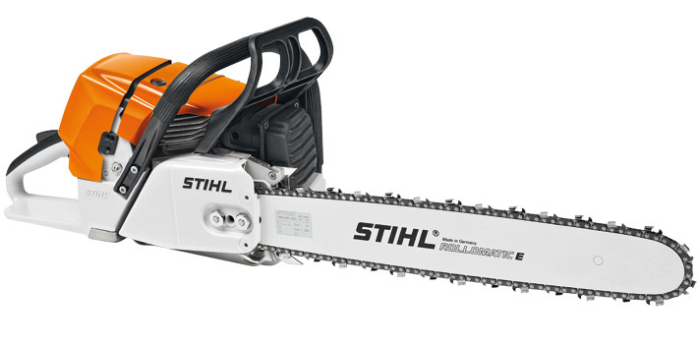

GENERAL INFORMATION

Both Stihl MS 460 and Stihl MS 461 are powered by a 2-cycle gasoline engine. Lubrication of the engines is accomplished by "premixing" the gasoline with a lubricating oil at a fuel to oil ratio of 50:1. Premix cans used by the Department are available from the saw shop at station 17. Fuel should be used within 1 year of being opened.

Both Stihl MS 460 and Stihl MS 461 have a 20" Rollermatic bar equipped with an automatic chain oiler. To maintain correct chain lubrication, the oil quantity control bolt located on the bottom of the crankshaft should be preset to the maximum feed setting. There are two types of chains that are used on each type of saw:
- Wood Cutting chain to be used on all Type 3 wildland apparatus.
- Heavy-duty carbide chain (RDR) to be used on all structure and ARFF apparatus.

To check the chain tension

First, set the run switch to the off position. Second, with a gloved hand, pull the chain along the bar—the chain should feel snug to the bar and will pull with limited resistance.

To adjust the chain tension

First, ensure the mounting nuts on the guide bar are finger tight. Second, hold the bar nose-up and turn the guide bar adjuster screw to take out the slack. (The adjuster on both Stihl MS 460 and Stihl MS 461 is located on the side, between the bar nuts). Third, after making the adjustment, recheck the tension by the above method.

DAILY MAINTENANCE
- Check and fill fuel tank.
- Check and fill bar oil reservoir.
- Inspect and clean air filter.
- Inspect and clean cooling fins.
- Inspect and clean drive gear.
- Inspect and clean guide bar and roller tip.
- Inspect and clean chain.
- Check chain tension.

STARTING PROCEDURE:
- Disengage the chain brake.
- Squeeze throttle and set choke switch to “full”.
- On the Stihl MS 461 depress the decompression switch on the top of the saw. NOTE: This step is not necessary on the Stihl MS 460.
- Anchor the saw firmly and pull the starter cord until the engine “burps”.
- Move the choke switch to the “HALF” position.
- Anchor the saw firmly and pull the starter cord again until the engine starts.
- Squeeze the throttle to disengage high idle. NOTE: The choke switch will shift to the “I” or run position after high idle has been disengaged.
- With the engine running, check the function of the chain oiler by holding the tip of the guide bar close to the ground or a piece of cardboard. A thin line of oil should appear when operating the saw at full throttle.
- With the engine running, check the function of the chain break by pushing the break forward to stop rotation. Pulling the chain break back toward the handle should restore free rotation.

STOPPING PROCEDURE:
- Idle the saw to dissipate the heat.
- Switch the control switch to "OFF" or "STOP".

STORAGE PROCEDURE:
- Allow the saw to cool.
- Disengage the chain break.
- Set choke to “FULL”.
- Wipe the saw clean of residue and debris.

Cutoff Saws

Federal Fire Department San Diego uses three (3) types of Cutoff Saw
- Stihl TS 700 (Figure 1).
- Husqvarna K960 (Figure 2).
- Husqvarna K970 (Figure 3).
Figure 1

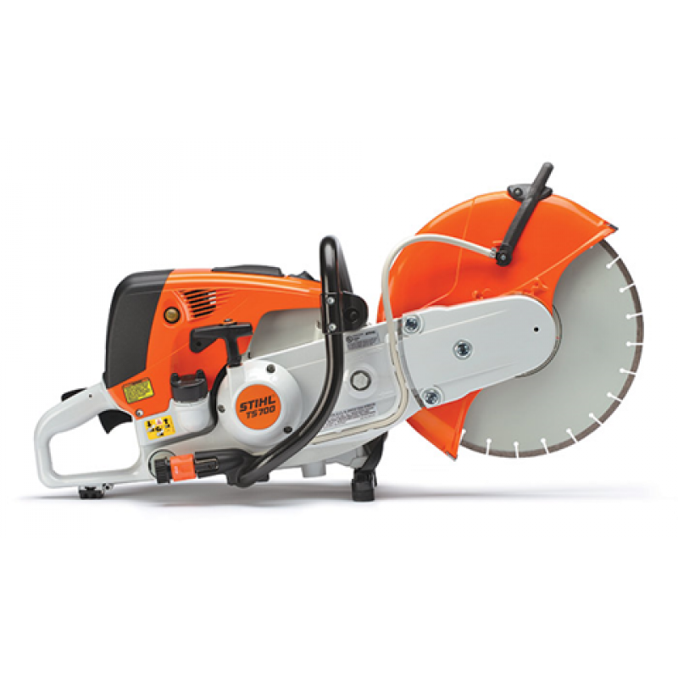

Figure 2

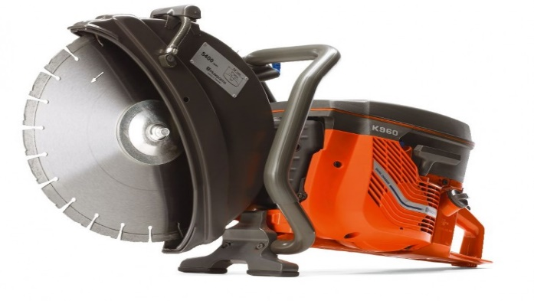

Figure 3

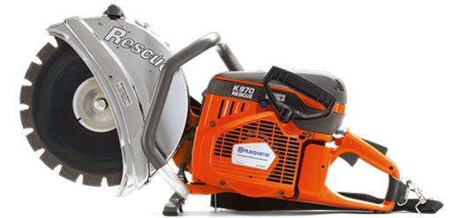

GENERAL INFORMATION

All the department cutoff saws (Stihl TS 700, Husqvarna K960, Husqvarna K970) are powered by a 2-cycle gasoline engine. Lubrication of the engines is accomplished by "premixing" the gasoline with a lubricating oil at a fuel to oil ratio of 50:1. Premix cans used by the Department are available from the saw shop at station 17. Fuel should be used within 1 year of being opened.

All the department cutoff saws (Stihl TS 700, Husqvarna K960, Husqvarna K970) use a "V" type drive belt that needs no lubrication. These belts should be checked daily and replaced when noticeably cracked and/or worn.

he drive belt on the Husqvarna K960 and Husqvarna K970 is maintained by a pressure spring. To set the tension, slightly loosen the bolts which secure the cutting head and the belt guard. Turn the tensioning screw located on the mounting arm clockwise to set the proper tension and re-tighten the bolts that hold the cutting head.

The belt tensioning system on the Stihl TS 700 is automatic. If issues arise with belt tension, contact the Saw Shop at Station 17.

All the department cutoff saws (Stihl TS 700, Husqvarna K960, Husqvarna K970) have a 1” arbor with a 14” blade. When selecting a blade, ensure the proper blade type is being used for the material being cut. Further, ensure the MAX RPM of the blade is greater than or equal to the MAX RPM of the saw.
- The Stihl TS 700 has a MAX RPM of 5350.
- The Husqvarna K960 has a MAX RPM of 5400.
- The Husqvarna K970 has a MAX RPM of 5400.

DAILY MAINTENANCE:
- Check and fill fuel tank.
- Inspect and clean air filter.
- Inspect and clean cooling fins.
- Inspect and adjust drive belt.
- Inspect and select proper cutting disk.
- Inspect and adjust cutting disk guard.
- Inspect and tighten all loose nuts.
- Inspect pull cord.

NOTE: Replace spark plugs and air filters every six (6) months.

STARTING PROCEDURE—HUSQVARNA K960, HUSQVARNA K970:
- Depress the compression release valve located on the top or left side of the engine.
- Push the top control to the forward or run position.
- Pull the choke control backwards to the closed position.
- Set the throttle trigger by pressing the throttle catch on the side of the handle.
- Secure the saw and pull the starter cord until the engine starts
- Release the starter cord.
- Allow the engine to warm up.
- Adjust the choke as needed.

STOPPING PROCEDURE—HUSQVARNA K960, HUSQVARNA K970:
- Idle the engine to dissipate engine heat.
- Pull the stop control backward.

STARTING PROCEDURE—STIHL TS 700:
- Press and hold the throttle trigger lockout.
- With the throttle trigger lockout held, press and hold the throttle trigger.
- With both the throttle trigger lockout and throttle trigger held, move the master control lever to “START”.
- Set the choke switch on the left side of the engine to the down position.
- Press the decompression valve on the top of the engine.
- Press the fuel primer bulb 7-10 times. NOTE: The bulb must be pressed repeatedly even if the bulb appears to be filled with fuel.
- Anchor the saw firmly and pull the starter cord until the engine “burps”.
- Place the side choke level to “HALF” and press the decompression button again.
- Anchor the saw firmly and pull the starter cord again until the engine starts.
- Run the saw at full throttle with the side choke level at “HALF” for 30 seconds.
- Flip the choke to open.

NOTE: If the carburetor has been set correctly the cutting disc should NOT spin while the idling.

STOPPING PROCEDURE—STIHL TS 700:
- Idle the engine to dissipate engine heat.
- Slide the master control level to “STOP” or “0”.

STORING PROCEDURE—HUSQVARNA K960, HUSQVARNA K970, STIHL TS 700:
- Allow the saw to cool.
- Set choke to “FULL”.
- Press the decompression switch.
- Wipe the saw clean of residue and debris.

