Usage:
- Is a completely self-contained cutting system. It includes both fuel and oxygen cylinders.
- Recommend setup is for short-term steel cutting where portability is important.
- The PCS will cut 1/4-inch steel for 25 minutes; 1-inch steel for 13 minutes; 4-inch steel for five minutes. The fuel tank holds 1.5 quarts of fuel, which will last for about 1.5 hours of non-stop cutting. Cutting time is limited by oxygen supply.

Specifications:
Tip # Oxygen % Tip # Oxygen %
0 15 5 60
1 & 81 20 6 70
2 30 7 80
3 & 83 40 8 90
4 50

Equipment:
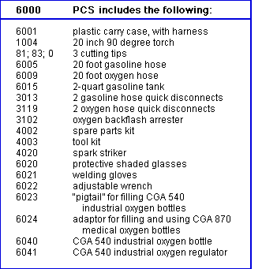

operations:
Lighting
- Open gas tank value slowly to prevent emergency shut off
- Purge the oxygen line for at least 5 seconds before igniting the torch
- Open the pre-heat oxygen first
- Then open the gasoline until you see a light mist. You should never see dripping gasoline while operating the torch.
- Purge oxygen line again
- Torch is ready to light
Shutting down the Torch
- Close the torch gasoline first
- Then close the Torch pre-heat oxygen valve
- Make sure the gasoline tank filler cap is closed
- Close the gasoline tank shut-off valve
- Leave the tank, torch and hose connected for storage to avoid gasoline spillage
- Make sure there are no visible leaks

maintenance:
- Tighten hose connectors at torch butt with hex wrench
- Tighten torch packing nuts under hand wheels
- Tighten tank packing nut under hand-wheel of shutoff valve
- Wait until the torch head is cool before tightening the tip nut

