Usage:
Capable of standard drill or rotary hammer through concrete, steel or wood.

Specifications:
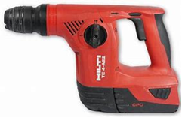
- 24V Battery
- RPM 0-1200
- BPM 0-4400
- Bit Type SDS Plus
- Weight 9.2lbs
- Max Capacity
- -Concrete 7/8”
- -Steel ½”
- -Wood ¾”

safety:
- Do not force tool
- Always use side handle
- Do not use dull or damaged bits
- Ensure bits are secure prior to use
- Be aware of surroundings

operations:
- Make sure tool is in off position
- Depress locking sleeve
- Insert proper bit (make sure bit is locked in)
- Set depth gauge if applicable
- If internal slip clutch engages (bit will bind up) release trigger and reposition tool
- After use remove bit and store tool in stand by position or remove battery

maintenance:
- Rotate battery per weekly battery charging schedule. (Page 78)
- Remove battery, clean tool with compressed dry air
- Wipe down body

