Usage:
The Hilti Sawzall can be used to cut different materials from wood, glass, plastic and metal.

Specifications:
Hilti Sawzall
- 36V. battery powered
- Li-Ion
- Does not develop a memory
- Can cut up to 60-2x4’s on one charge
- To be charged for 5-40 min. when low
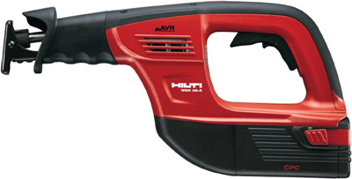
- Discharges 1% per day without use
- Trigger speed control switch from0-2,850spm
- 0-2,700spm without load
- 1 ¼” Stroke Length
- 3.5” min. blade length
- Weight: 9.6lbs
- Length:17.3”
- Blades: Wood, Metal, Bi-Metal
- Must extend past the object to be cut
- Blade can be inserted blade up or down
- ½ Keyless Chuck-Twist Lock Collar
- Spare blades and battery stored in vehicle

operations:
- Hold by the grip and the forward grip
- Squeeze trigger for desired blade speed
- Blade should be operated prior to contacting the cutting surface
- Can be used to make plunge cuts
- Placing the tool shoe on the cutting surface will reduce vibration

maintenance:
- Clean and wipe down after each use
- Inspect blade for wear and replace if necessary
- Inspect and clean battery contacts

