Usage:
Used to quickly stabilize vehicles before extrication is conducted.

Specifications:
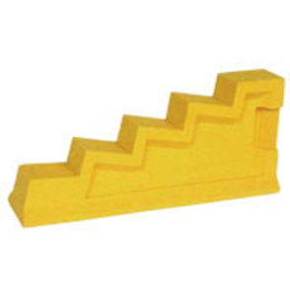
Chocks
- Made by Turtle Plastics
- Constructed from 100% recycled plastic
- 25”x51/2”(base)x11”
- 31/2” wide step
- Twice as strong as oak wood
- Gas, oil, chemical, and blood resistant
- Weight: 22lbs.

other Equipment:
- Wedges
- Shims
- Additional Cribbing

operations:
- Place Chocks in desired locations under the vehicle.
- Shims can be used to fill gaps and create a tighter fit
- The vehicle can be lifted slightly to create a tighter fit as well

maintenance:
- Remove dirt and debris by wiping down
- If necessary clean with soap and water
- Inspect for cracks, wear and material breakdown

