Usage:
Usage: For access to roofs, windows, and other objects overhead. Ladders can be used in rescue, ventilation, distribution of weight, as well as shuttle activities.

Specifications:
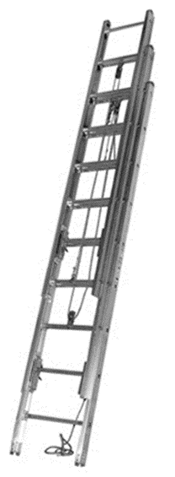
- Lengths:
  - Attic (folding): 10’
  - Combination: 14’
  - Roof: 14’ & 16’
  - Extension: 24’, 28’, and 35’
- Ratings:
- Extension/Roof Ladders: 750Lbs with a 4:1 safety ratio
- Roof Ladder Hooks: ¾” Hooks rated at 1,000Lbs and 2,000Lbs together
- Attic Ladder: 300Lbs with a 4:1 safety ratio
- Rung Distance: 14” on center and 1¼” in diameter
- Rungs welded and extruded to beams
- Constructed of 6061 T6 Aluminum
  - Min. yield 38,000psi
- Welds withstand 8,000psi
- Conduct Electricity
- Meet NFPA 1931 and 1932 specifications
- 4 Heat sensors per section
- Change from orange to black/brown at 300 o +/- 5 o
- Maintain 75% of strength at 300o
- Halyard (when applicable) constructed of nylon per FFDSD

operations:
- Remove appropriate size ladder from apparatus
- Place spot and raise ladder in safe, desired location
- Butt of ladder should be placed ¼ of the working height of the ladder
- Proper climbing angle should be set to 75o
- Raise fly and secure halyard
- Foot ladder and secure with webbing or hose rope tool

maintenance:
- Clean ladders with mild soap, water and soft brush
- Mfg. recommends paraffin wax lubricant
- Check rungs, welds, dogs, pulleys, stops for snugness and damage
- Inspect halyard for abrasions and deterioration
- Check heat sensor labels
- Vehicle soap may change heat sensor label color

Safety precautions:
- Wear full turnouts
- Watch hand placement when extending and retracting fly
- Lift with legs not back
- Tie off excess halyard to prevent tripping
- Tie beam off to solid object to stabilize ladder
- Watch for above and under ground sources of electricity

