Federal Fire Department
Shipboard Fire
Company Laboratory Training

FFDSD Shipboard Firefighting Training

Critical Safety Points:
NFPA Standard:  1005/1403/1405 | Terminal Objective:  Effective Hose Handling Procedures  Proper Thermal Imaging Techniques | Dept. Sop # :  176
Equipment Required: 100’ 1 ¾ firefighting, Full PPE, Thermal imager, Forcible entry tools |  | Apparatus or Specific Equipment:
Member Instructions: Member will be able to successfully access and conduct interior operations utilizing appropriate equipment and effectively relive ships fire company while performing firefighting duties onboard a marine vessel.
Instructor / Operators Instructions: (See RTC Shipboard SOP for position descriptions)

Pre Drill Structure Layout
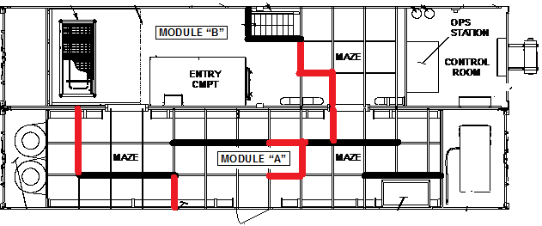
Hose Handling |  | lab #1
1. | Effective watertight enclosure entry
2. | Proper hose movement through ship passageways
3. | Proper choke/friction point negotiations with 1 ¾ hose line
4. | Effective interior communications between CO and FF  (Verbal / Non-verbal)
5. | Effective Nozzle person relief (with agent on fire)
6. | Tactical back out

interior hose team relief |  | LAB# 3
1. | Communicate the need for hose team relief
2. | Utilizing accountability procedures access the IDLH environment following 1 ¾ attack line.
3. | Relief team communicates with attack team and gives clear instructions on role.
4. | Attack team company officers complete a face to face brief prior to relief.
5. | Relieved attack crew gathers at accountability site with CO and proceeds to rehab.

accessing watertight compartment |  | lab #2
1. | Identify operation of Thermal imager, battery usage and change out.
2. | Ensure company is briefed on tactics and strategy prior to entry
3. | Test agent and pattern of hose stream
4. | Ensure forcible entry equipment is available
5. | Check watertight door/hatch/scuttle for heat with appropriate pressure relief tactics. Identify interior conditions through relief process
6. | Open watertight door/hatch scuttle and make a direct attack

