Usage:
Used for lifting, pushing, spreading, bending, pressing, or straightening objects up to 12 tons. Can work in upright, angle or horizontal positions

Specifications:
- Lifting capacity of 5 tons
- Height 9” (Retracted)
- Total extension 18.5”
- Screw extension 3 1/8”
- Ram extension 6”
- Three piece handle 22”

safety:
- Do not exceed load limit.
- Stabilize load before lifting.
- Watch for load weight shift.
- Watch for potential pinch or crushing hazards

operations:
- Connect 3 piece handle
- Close valve by turning clockwise
- Insert handle into hydraulic pump, begin pumping
- To lower place handle on valve, slowly turn counter-clockwise two turns

maintenance:
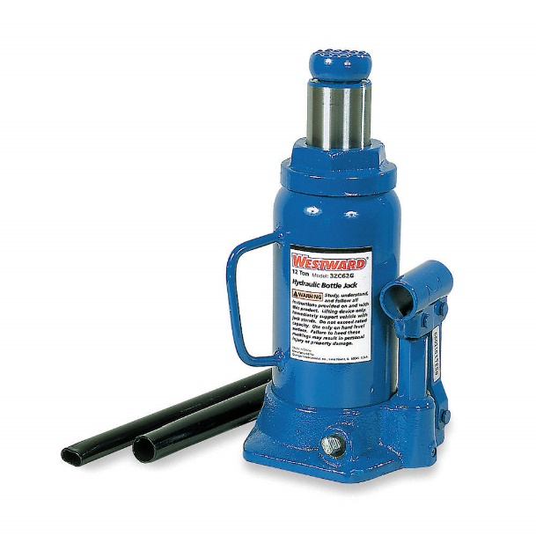
- Wipe down tool
- Insure tool is functioning properly
- To add or change oil, push ram down remove rubber plug and fill to level of hole with hydraulic jack oil.

